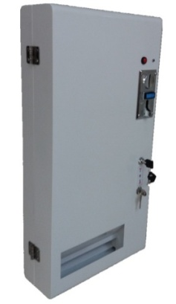
- Currency：free to program up to 6 kinds of coins.
- Stock Sense：Machines stops working if goods is out of stock.
- Output Rate：under 3 seconds
- Goods Capacity：around 70 pcs
- Voltage: DC+12V
Note: Free to use battery case with 8 pcs of AA BATTERY or 12V2A adaptor

Dimension and Weight
Machine Size : 63cm*32.5cm*12cm Goods Size : 2*5.5*7.5cm
Packing Size : 71cm* 40cm*22cm
Money Box Size: 10.5cm*4.5cm*16.5cm (self-provided)
Weight ：10.5KG
Installation Step
- Plug power by battery case or 12V2A adaptor. 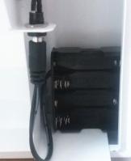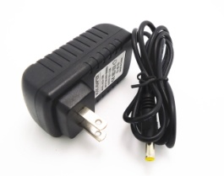
- Put on goods 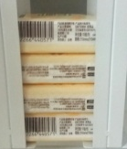
- Put iron sheet 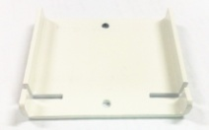 upon goods 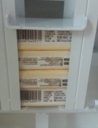
USEAGE
- Push button. LED lights.
- Insert coins and get 1 pcs of item.
- Self power off after stay by 10 seconds.

