Connection
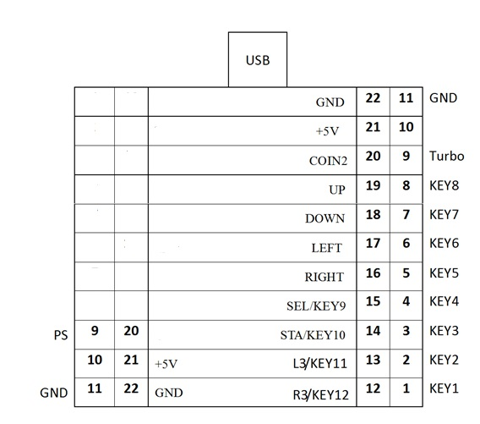
Test PC/PS3 2 in 1 Jamma controller on Win7 or Win8 as Example
- Please plug USB wire from main board to computer.
- Control Panel-> hardware and sound-> Devices and printers
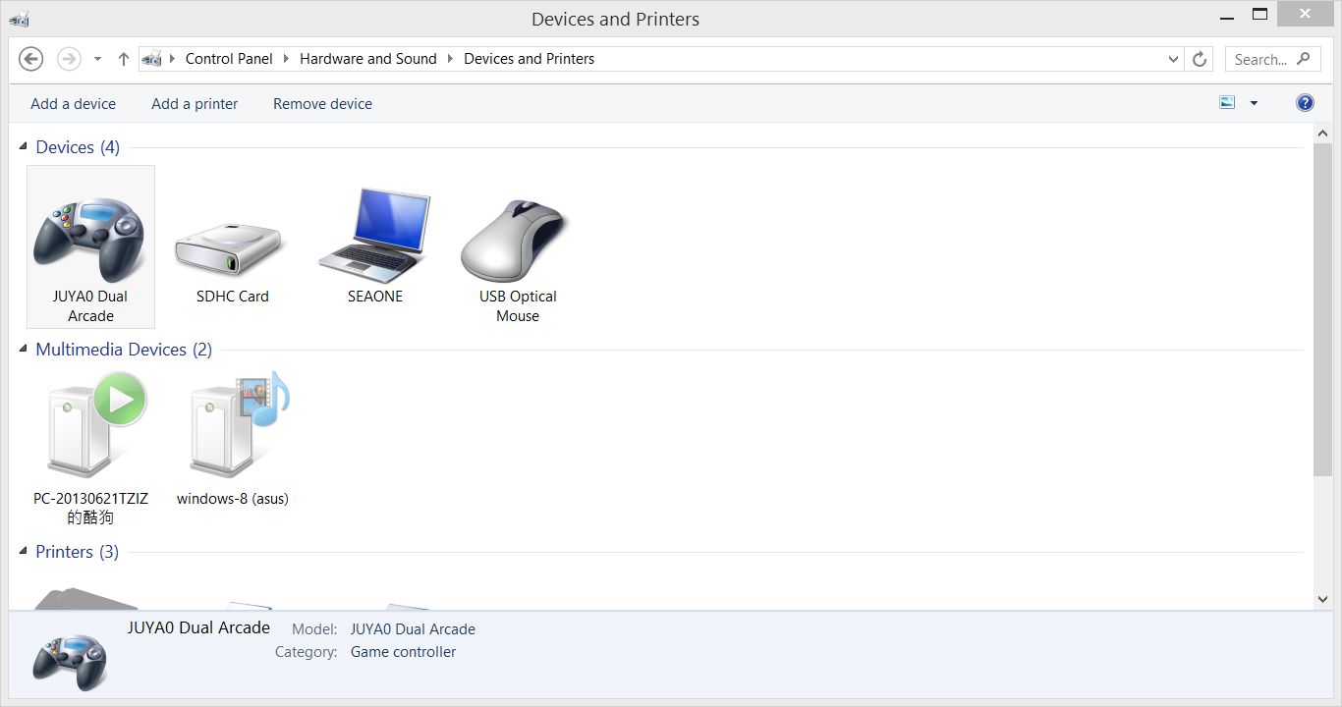

- Please click mouse right, and choose 4. Please click the option for testing.
“Game controller settings”.
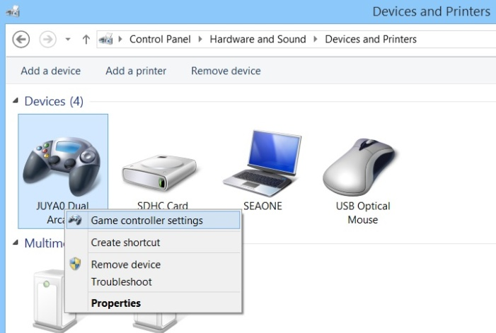 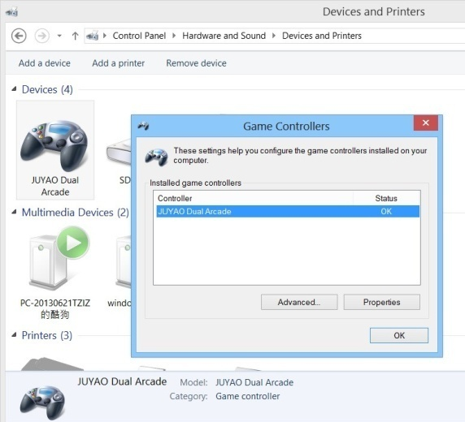
- Testing Panel
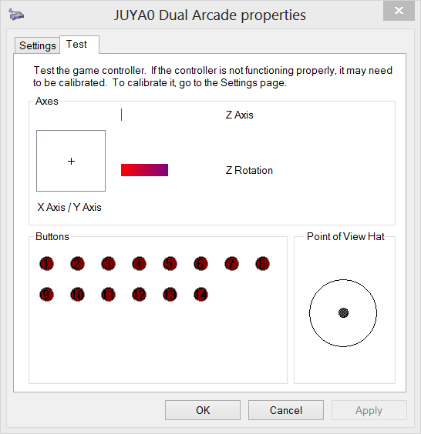
Button Turbo :
- Turn on function turbo-
Please hold on button Turbo, and press a button which needs to be functional.
- Turn off function turbo-
Please hold on button Turbo, and press the button again which needs to be non-functional.
Note: only button 1-button 8 can be set up for turbo.
Button PS:
- Button PS works only with PS3 for returning to menu.
- It is a button as usual when it works with PC.
Button 20:
- Please hold on button 20 for switching left joystick to right joystick
up down left right

