- LOG IN 2. Change password and department on REPORT
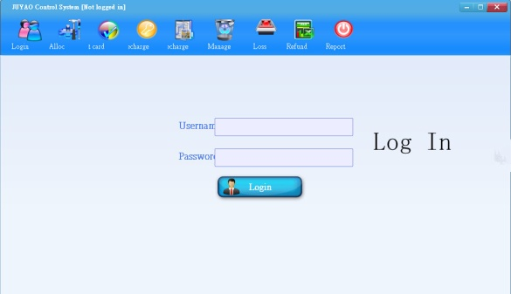 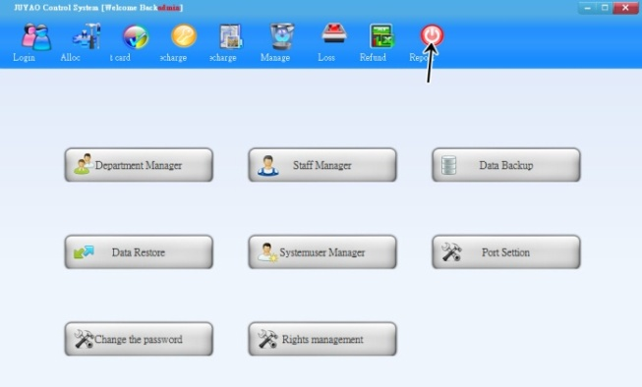
Button Note for Report-> department manage
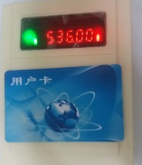
3.
Please put on membership card on RECHARGE MACHINE.
- If membership card is new, please ALLOCATE card first.
- Free to RECHARGE If membership card is allocated card already
- ALLOCATE CARD: Click manually alloccard and fill in information.
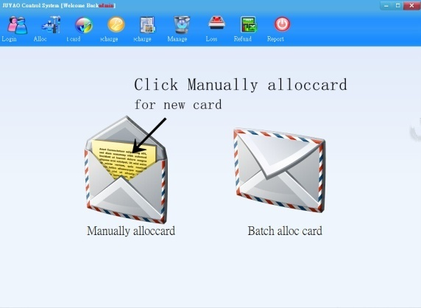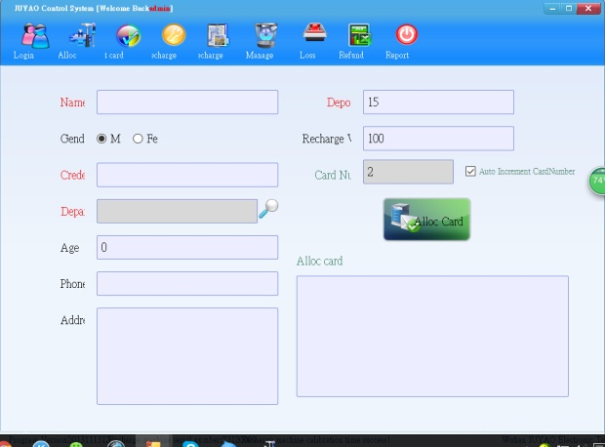
- RECHARGE TO MEMBERSHIP CARD:
Click “Read Card”-> Type down value->click Recharge
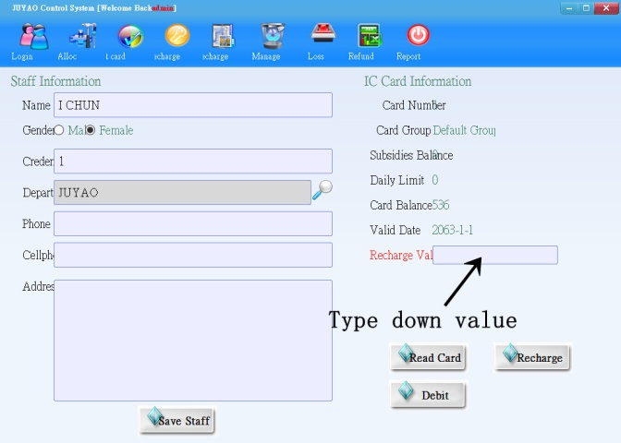

- Set up PRICE for sense 1 time - MAX:250CENTS:
(1) 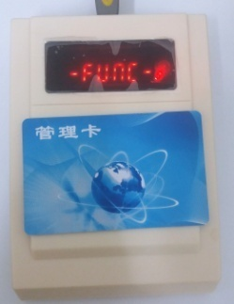 (2) 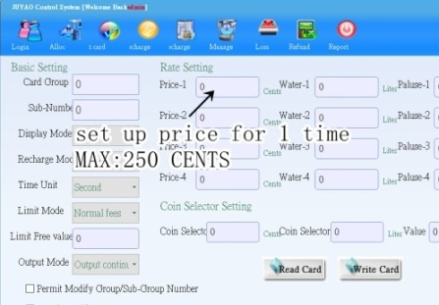 (3) 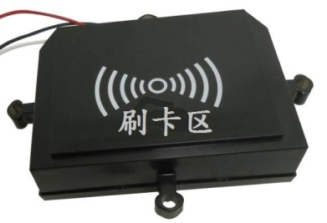
1. Please put on MANAGER CARD (1) ->
Click “Read Card” -> Type down price on” Price-1” -> Click “Write Card” (2).
2. Please use manager card to sense CARD READER (3).
- USAGE for CARD READER
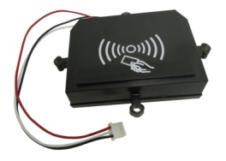
Use membership card to sense card reader:
- First sense: Card reader shows BALANCE
- Second sense: deduct credit from balance.
Connection: RED WIRE: DC+12V
WHITE WIRE: OUTPUT SIGNAL
BLACK WIRE: GND

